

REIMBURSEMENT

MANUAL

Table of Contents

1. Introduction to SharePoint 3

1.1 Your SharePoint Site 3

2. Sharepoint Terminology 3

3. How To Log Into Your SharePoint Site 4

4. Logging Out of SharePoint 4

5. About Reimbursement 5

5.1 About the application 5

5.1.1 Reimbursement – Objectives 5

5.2 ROLES 5

5.2.1 Reimbursement Roles – Users and their Roles 5

6. Reimbursement Operation 5

6.1 Logging In to your SharePoint site 5

6.1.1 Reimbursement - Access to Sales Site 5

6.1.2 Reimbursement – Applying for Trip Ticket 7

6.1.3 Reimbursement – Applying for Expense Request 9

7. Reimbursement Management 11

7.1 Reimbursement – Approving Reimbursement Ticket 11

7.2 Reimbursement – Rejecting Reimbursement 12

7.3 Reimbursement - Releasing of Reimbursement 13

# Introduction to SharePoint

## 1.1 Your SharePoint Site

Microsoft was implemented at the **Microgenesis** to enhance collaboration. Microsoft also has some other useful tools such as a calendar, which can help you plan and work on projects together. SharePoint is not a file storage system.

Your SharePoint team or Division site will be known as the primary site collection or top-level site. This is because it is possible to create more sites within it for specific and limited teamwork. These extra sites are known as subsites.

Your site will be based on a team site type chosen to most closely reflect your team’s requirements. The team site type will have a ready-made layout for libraries and additional resources such as calendars and tasks. The site can then be modified to suit your team requirements.

# Sharepoint Terminology

|  |  |
| --- | --- |
| Terms | Description |
| SharePoint Site | The SharePoint site is the overall **Microgenesis** SharePoint site from which department and team sites are created. |
| Primary Site Collection | Each team or department site is a site collection. |
| Subsite | A team site within an existing primary site collection. |
| Library | A library can be created to hold a certain type of file or document or relate to a particular project or task. |
| Folder | Folders can be used to group document and files. |
| Nominated Primary Site owner | The owner of your team or department site. The Site Owner is responsible for all the content on the site and how it is used. They are also accountable for the entire site including subsites. |
| Nominated Subsite owner | Responsible for the subsite they create, all the content and how it is used. |
| Permissions | These are set by the Site Owner and will determine what libraries, folders or documents a SharePoint user can share, edit or view. |
| Collaboration | Sharing work in SharePoint. Most collaboration will be on shared documents where several SharePoint users may be updating the same documents. |
| Document Sharing | To share a file or document with a SharePoint User for collaborative working or just to view the content. |
| SharePoint End User | Everyone who has permissions to use the content of a site, other than the Site Owner. |
| SharePoint Calendar | A shared calendar for everyone in the SharePoint team to view. |
| SharePoint Tasks | Shared tasks for everyone in the SharePoint team. Can be used to keep track of group projects and assign tasks to a particular SharePoint user. |
| Contacts | Shared contacts for everyone in the SharePoint team to use. Can be exported and used in Outlook if required. |
| Ribbon | A context sensitive menu bar which appears at the top of a SharePoint page. |
| SharePoint Page | A SharePoint screen of information. |
| Lists | A list of contacts or tasks within SharePoint. |

# How To Log Into Your SharePoint Site

Most users of SharePoint will receive a link to your site through the email in the way of an invitation to join the SharePoint team site. By clicking on the link, you will then have access to your site.

Because SharePoint uses windows authentication using Active Directory, there will be a user login notification that will require your credentials. Follow the instructions below:

* Type your domain username and password
* You will be directed to SharePoint immediately.

# Logging Out of SharePoint

To ensure you are fully logged out of SharePoint follow the instructions below.

1. Click the drop-down arrow , which is to the right of your user name at the top right hand corner of the SharePoint team site window.
2. Click **Sign Out**

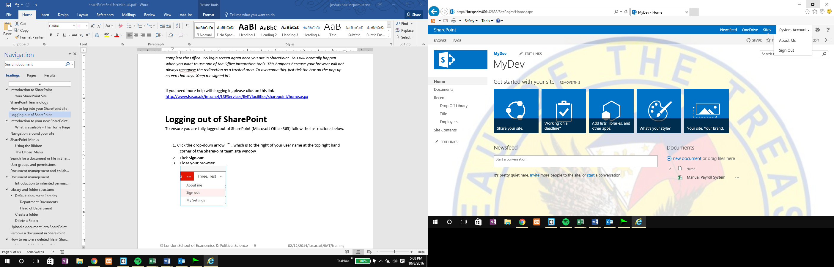

1. Close your browser

# About Reimbursement

## 5.1 About the application

* **REIMBURSEMENT APPLICATION –** automation of the manual process of trip ticket, representation and other expenses of sales. It is the second phase of the automation project of LOU.

### Reimbursement – Objectives

* To automate and easy tracking of Trip Ticket and Expense Request per Account Manager
* To monitor trip ticket and expense request approval by Sales Manager
* To generate report of all reimbursements by Custodian

## 5.2 ROLES

### 5.2.1 Reimbursement Roles – Users and their Roles

|  |  |
| --- | --- |
| User | Roles |
| Employee | Requestor of the application |
| Immediate Supervisor | Approver of the request |
| Custodian | Generate all reimbursement requests |

# Reimbursement Operation

## 6.1 Logging In to your SharePoint site

### 6.1.1 Reimbursement - Access to Sales Site

**Step 1:** To access Sales Site. Go to[*https://mgenesis.sharepoint.com*](https://mgenesis.sharepoint.com)



**Step 2:**  Log-In using an outlook email and password.

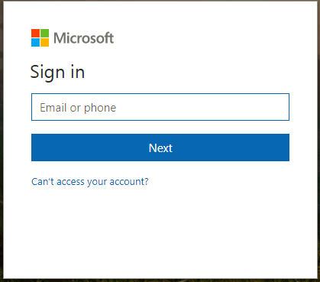 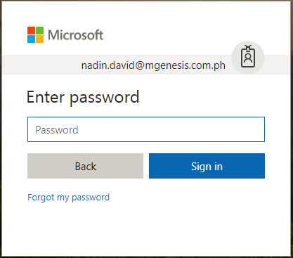

**Step 3:** Select Sales tab to access sales site.



**Step 4:** Select Reimbursement Library to view Reimbursements.

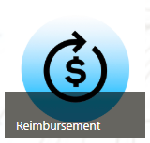

### 6.1.2 Reimbursement – Applying for Trip Ticket

* *To create a reimbursement user must apply for a LOU first. LOU and Trip ticket are connected to each other.*

**STEP 1:** Select Letter of Understanding Library tab

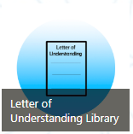

**STEP 2:** Applied LOU shall appear, select a LOU application and click “Edit”

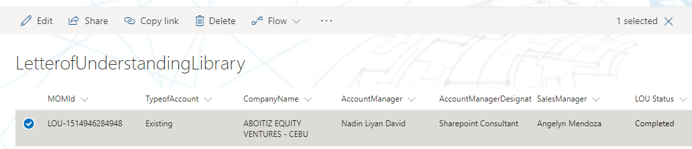

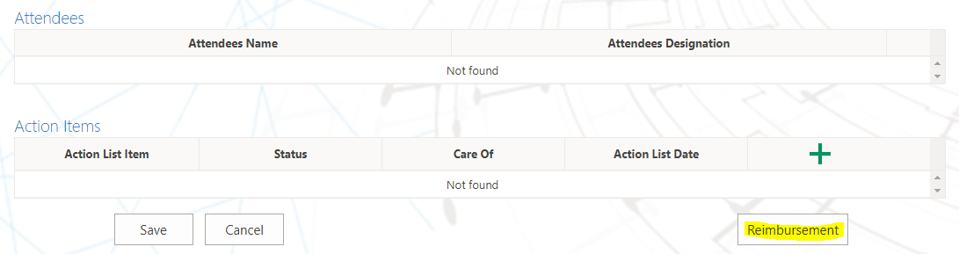**STEP 3:** User shall scroll down, click Reimbursement

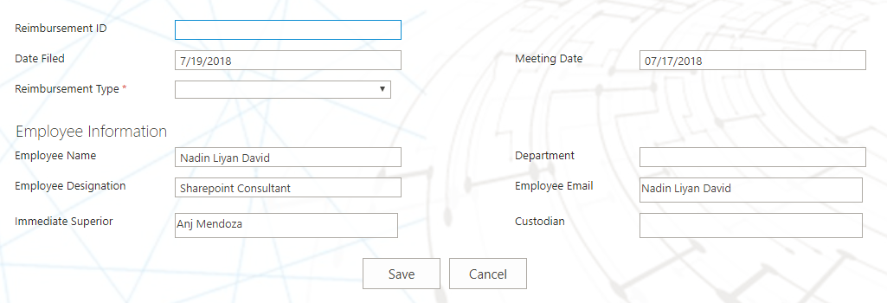**STEP 4:** User shall be redirected to Reimbursement form

**STEP 5:** Fill-up trip ticket form.

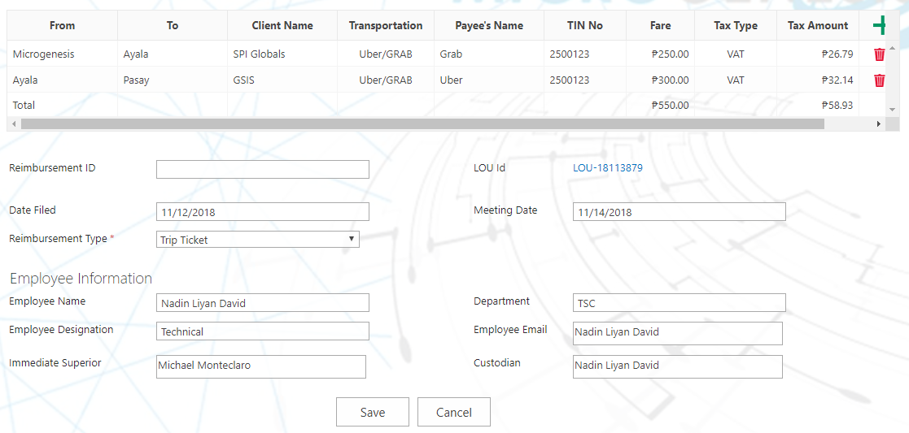

**STEP 6:** Click Save



**STEP 7:** Request shall be saved on the reimbursement library

### 6.1.3 Reimbursement – Applying for Expense Request

* *To create a reimbursement user must apply for a LOU first. LOU and Trip ticket are connected to each other.*

**STEP 1:** Select Letter of Understanding Library tab



**STEP 2:** Applied LOU shall appear, select a LOU application and click “Edit”



**STEP 3:** User shall scroll down, click Reimbursement

**STEP 4:** User shall be redirected to Reimbursement form

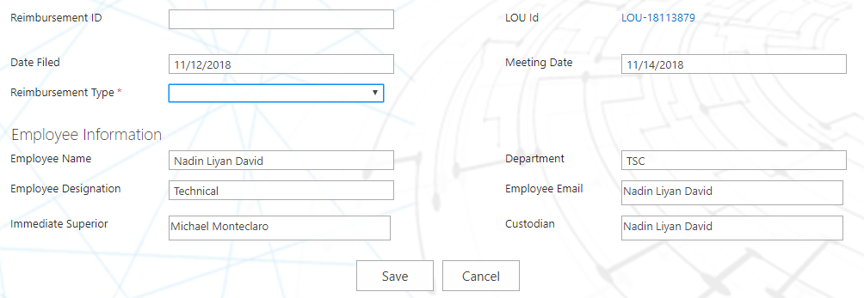

**STEP 5:** Fill-up table.

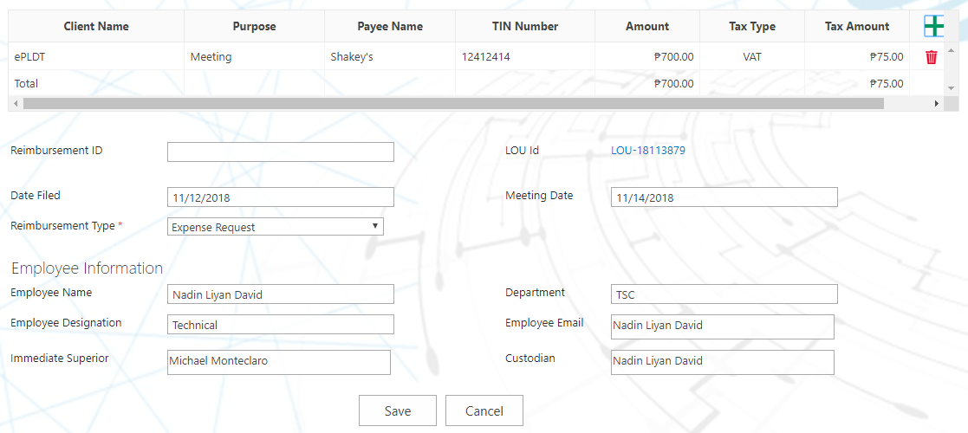

**STEP 6:** Click Save



**STEP 7:** Request shall be saved on the reimbursement library

# Reimbursement Management

### Reimbursement – Approving Reimbursement Ticket

**STEP 1:** Sales Manager shall receive an email notification for reimbursement approval.

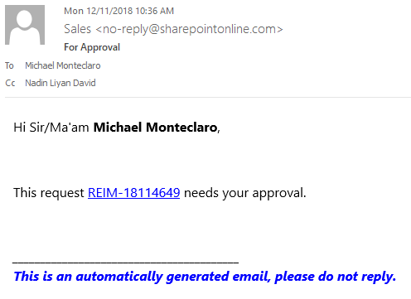

**STEP 2:** Click ***Reimbursement ID*** to be redirected to request form



**STEP 3:** Click ***Approve*** button



**STEP 4:** Request status shall be updated to ***“For Release”.***



### Reimbursement – Rejecting Reimbursement

**STEP 1:** Sales Manager shall receive an email notification for request approval.

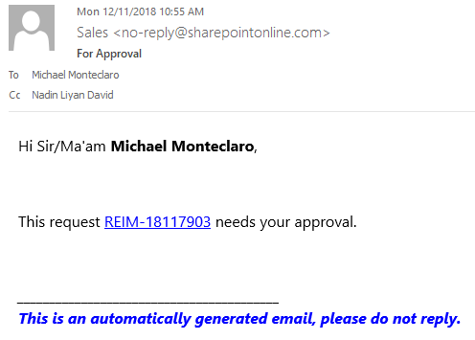

**STEP 2:** Click ***Reimbursement ID*** to be redirected to Reimbursement form



**STEP 3:** Click reject button



**STEP 4:** Request status shall be updated to ***“Rejected”.***



### 7.3 Reimbursement - Releasing of Reimbursement

**STEP 1:** Custodian shall receive an email notification for reimbursement approval.

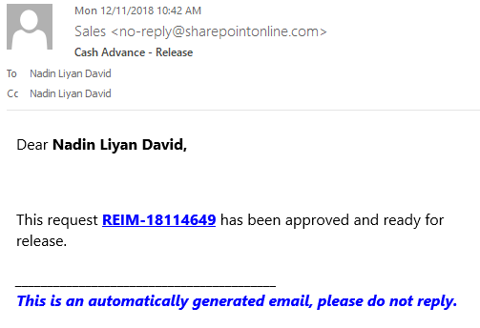

**STEP 2:** Click Reimbursement ID to be redirected to the form.



**STEP 3:** Click release button, a dialog box shall appear for code input.



**STEP 4:** Requestor shall input code to acknowledge that the cash has been received.

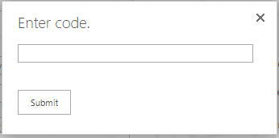

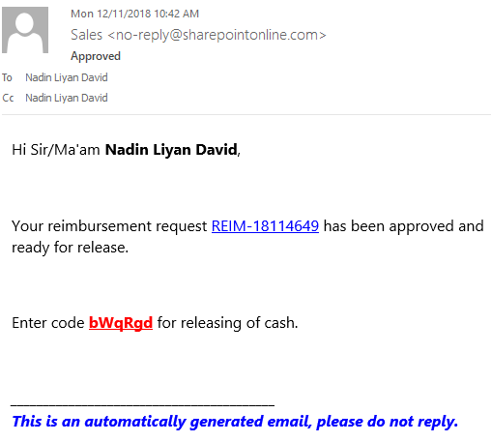

**STEP 5:** Request status shall be updated to ***“Acknowledged”.***

